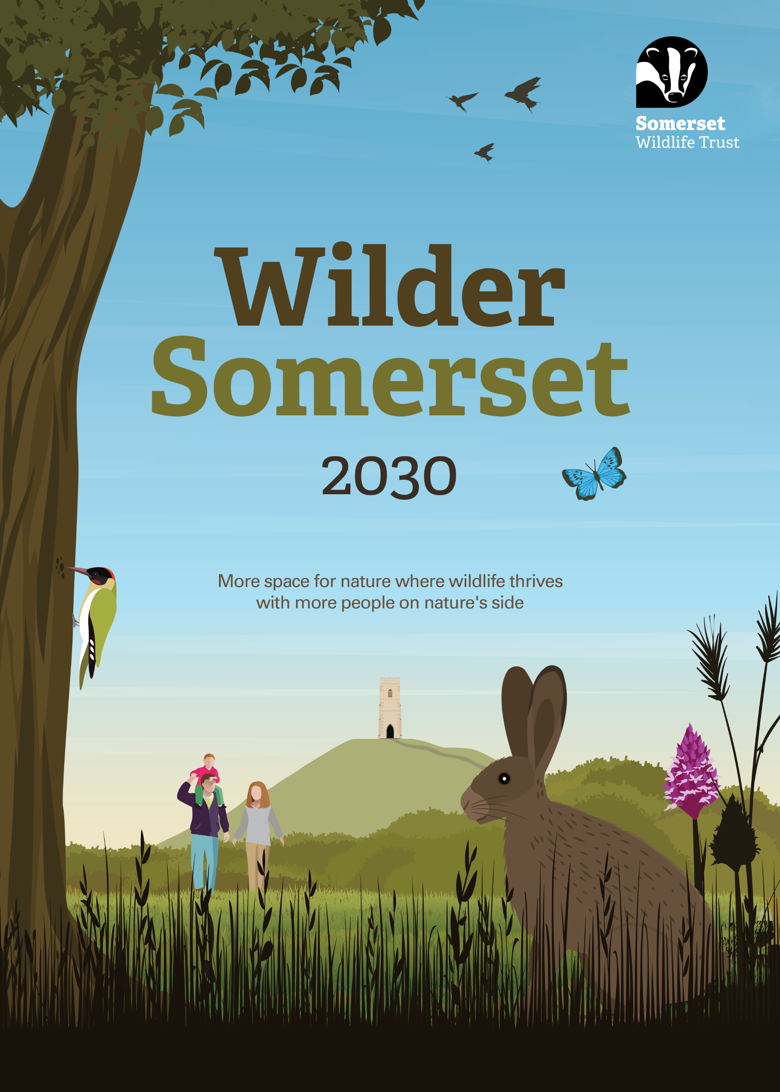



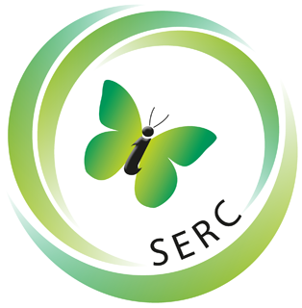

Job description:
SWTC Arboriculturist

About Somerset Wildlife Trust
Somerset Wildlife Trust is a local independent charity with a commercial subsidiary. We are the only organisation uniquely focused on improving the natural environment of Somerset for the benefit of wildlife and people. We protect, and lead the recovery of Somerset’s stunning, diverse, and important natural environment, making the case for nature to the public and politicians.

Somerset Wildlife Trust is one of 46 Wildlife Trusts, and one of 25 Wildlife Trust Consultancies across Britain which together with the Royal Society of Wildlife Trusts collectively form The Wildlife Trusts. We are the biggest movement in the UK working solely for nature and we believe that restoring nature on a landscape scale is essential for tackling climate change and biodiversity loss.

The climate and ecological crises require comprehensive, ambitious solutions and urgent action across all sections of society. The crises are also inexorably linked so it is vital that our new strategy, 'Wilder Somerset 2030' is delivered with both at its core. We recognise that people are part of the solution and everyone has a role to play in restoring nature and averting the worst of the climate change. Research suggests that if 1 in 4 people in society take action then social tipping points can be achieved and widespread positive change can happen. This underpins one of our key strategic goals and Team Wilder is our delivery approach to inspiring and empowering others to help nature recover.

Our New Vision

To deliver a Somerset wide nature recovery network creating more space for wildlife, benefiting everyone, and playing its part in helping us reverse biodiversity loss and tackle the climate crisis.

Our New Mission

To champion the change needed to rebalance our relationship with wildlife and the natural world.

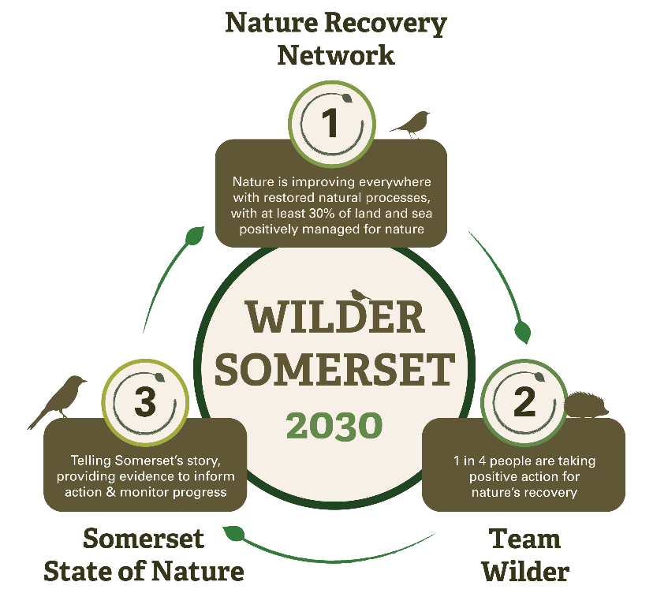
Our Goals for 2030:

To ensure that nature is improving across the county, supported by restored natural processes, and is connected and protected through a Nature Recovery Network, with at least 30% of land and sea managed positively for nature.

For nature to be valued and protected by everyone, building a movement with at least 1 in 4 people taking action for nature’s recovery across Somerset.
By 2030 to tell the story of nature’s recovery in Somerset through a shared, live online State of Nature tool that monitors progress and informs action.

About the post

The Arboriculturist role is a fantastic opportunity for an individual who is passionate about arboriculture, nature positive outcomes and enjoys and thrives on having variety in their working day. Each day will bring new challenges and interesting projects to apply your skills to and lead on. The role includes delivering a range of arboricultural consultancy and advisory services for a variety of projects and contracts; liaising with clients, contractors and statutory agents; assisting with managing project budgets and timescales, undertaking arboricultural surveys and the production of high-quality technical reports.

• Co-ordinate and undertake arboricultural surveys and prepare reports and plans to BS5837:2012 specifications (including pre-planning and construction stage support).
• Undertake tree risk surveys and reports.
• Produce woodland management strategies.
• Act as technical specialist to support clients with pragmatic solutions to complex issues, such as ancient trees and urban conflicts on interesting projects.
• Assist in the delivery of practical land management services.
• Support ecological surveys and mitigation works.

Job Title | SWTC Arboriculturist
Grade | Banding Level 3
Reports to | Line Manager
Team | Somerset Wildlife Trust Consultancy
Responsible for | Project delivery.
Job purpose | Project delivery, team management and business development.
Position | Permanent, part-time (22.5 hrs per week).
Notice period | 3 months
Location | Callow Rock Offices, Shipham Road, Cheddar, Somerset, BS27 3DQ / home working
Working relationships | Internal: All staff and trustees
Working relationships | External: Clients, suppliers and contractors
Benefits of working for Somerset Wildlife Trust | We offer some fantastic benefits including:  - 7% employer pension contribution  - Life assurance  - Annual professional institution subscription if applicable  - Payment of relevant licenses and tickets  - Flexible and agile working  - Wellbeing support – Employee Assistance Program, wellbeing champions  - Diversity networks through RSWT/TWT  - Paid volunteer days  - Continuous Professional Development opportunities  - 33 days of holiday (25 + bank holidays)  - Staff social calendar and events  The opportunity to make a real and positive difference to nature, communities and the climate

Job Description – Key Responsibilities and Tasks

Responsibility 1: Project Delivery

- Manage small to medium scale projects which require pragmatic and bespoke arboricultural services to enable the best possible outcomes for the client and wildlife.
- Plan the delivery of services by staff and sub-contractors and assist with the identification and resolution of resource limitations wherever possible to enable successful task completion.
- Work with colleagues to develop and refine existing and new services which meet the changing needs of clients and exceed industry standards.

Responsibility 2: Team Management

- May line manage an individual or small team of assistant arboriculturists.
- Provide leadership to colleagues in area of specialism.

Responsibility 3: Business Development

- Promote ecological services to new and existing clients via creation of appropriate content.
- Maintain and build relationships with existing and new clients and seek opportunities to expand partnerships which contribute to financial and Wilder Somerset targets.

General

- Continually develop skills and expertise which will improve the delivery of ecological services.
- Adhere to SWTC’s systems and procedures (e.g. timesheets, outlook calendar systems, file conventions).
- Comply with Somerset Wildlife Trust’s policies and procedures.
- Carry out other duties relevant to the post as requested by more senior staff within SWTC and also within SWT given line manager approval.
- Reflect Somerset Wildlife Trust’s values in all areas of work.
- Work collaboratively with other Wildlife Trusts to share learning and achieve greater impact collectively.

PERSON SPECIFICATION
To succeed in this role you will need to demonstrate:
 | Essentials | Desirables
Qualifications | Associate member of the Arboricultural Association or eligible for application  Educated to degree level or equivalent in a relevant discipline  Full driving licence and ownership of a personal vehicle.  An Arboricultural Qualification to Level 2 or higher, or demonstrable equivalent experience. | Technician member of the Arboricultural Association  Royal Forestry Society Certification  Outdoor First Aid.  Fit for work certified.  CSCS card holder  QTRA, PTI or VALID certified  Tree climbing and aerial rescue qualified  Brushcutter and/or chainsaw ticketed or eligible for certification.
Experience | A minimum of 2 years professional experience in a related role within an arboricultural consultancy (or similar).  Demonstrable commercial experience, with a determination to deliver high quality, timely and cost-effective services.  Arboricultural consultancy experience managing projects involving the delivery of arboricultural services.  Arboricultural consultancy experience completing tree surveys (to BS5837:2012), tree risk assessments and using relevant mapping software.  Experience of working with contractor gangs undertaking habitat works. | Client service experience including communication with clients via telephone, email and in person.  Ability to deliver tree climbing services and land management tasks including vegetation removal/spraying, tree surgery, planting and fencing.  Ability to offer specialist advice in a related discipline such as ecology or land advice.  Brushcutter and/or chainsaw experience or willingness to learn.
Knowledge | Detailed understanding of current best practice survey guidance for trees and woodlands.  Knowledge of legal requirements and planning systems and polices at a national and local level.  Awareness of environmental and biodiversity issues.  Excellent species identification and impact assessment skills. | In depth knowledge of related specialisms such as ecology and land management.  Knowledge of habitat management practices.  Strong awareness of protected species licensing requirements and systems.
Skills | Excellent communication skills; judging the frequency and method most appropriate to the situation and audience.  Highly competent in the use of Microsoft Office programs such as Word and Excel.  Ability to solve problems by proposing potential solutions rather than only highlighting issues.  Strong organizational skills and ability to prioritise work to achieve deadlines.  Ability to produce technical drawings using appropriate software. | Proven ability to manage personal time according to a fixed budget.  Experience using more specialist software such as AutoCAD, PTMapper or equivalent.  Proficiency in the operation and maintenance of hand-tools and machinery to manage habitats.
Attributes | Willingness and ability to undertake practical manual tasks outdoors in safe weather conditions and/or during anti-social hours as part of a team and where appropriate individually.  Committed to the delivery of outstanding client service.  Acute attention to detail being able to execute all tasks accurately.  Capacity and ability to sustain and succeed in a demanding post involving managing different priorities.  Able to follow specified systems and processes but also, where required, be willing to suggest system improvements.  Commitment to the highest levels of integrity, honesty and good governance.  Self-motivating and able to work on own initiative and be flexible to enable project delivery.  Exemplary professional conduct  Exemplary office conduct  Positive and approachable demeanor.  Determination to complete work which is of a very high standard within required timescales.  Eligibility to work in the UK without sponsorship. | An interest in the commercial aspects of the business including sales and marketing.  Ability to occasionally work away from home for short periods of time.




SOMERSET WILDLIFE TRUST’S WORKING VALUES AND EXPECTATIONS

Developing Somerset Wildlife Trust

To deliver our Wilder Somerset 2030 plan we, Somerset Wildlife Trust, will need to build our charity, be clear in our priorities and ensure our own actions support our aims. We have a new set of Values that will inform all our decision-making and actions to bring about nature’s recovery across Somerset.

- We are passionate about nature.

- We believe everyone can contribute to nature’s recovery.

- We love Somerset - its amazing wildlife and its communities.

- We are confident and brave in standing up for nature.

- We encourage innovative thinking and action for nature’s recovery.

To deliver our strategy we will:

- Support, inspire and enable others to act while leading by example.
- Develop a Climate and Environment Strategy that delivers on our own environmental commitments within the Trust covering all areas of our operation and land use including procurement, utilities, facilities, and transport to achieve carbon neutrality by 2030.
- Use our resources efficiently and effectively, harnessing the diversity, talent and commitment of our staff and supporters.
- Expand our supporter base and sources of income, including through embracing new opportunities to generate income streams that are compatible with our strategic goals and maintain financial stability.
- Embrace new ways to grow our impact and reach, with a particular focus on expanding our digital knowledge and experience.
