Pine Martens Bounce Back
The Two Moors Pine Marten Project

Creative Commission application form

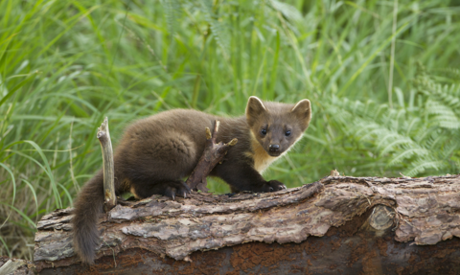
Photo: Mark Hamblin/2020VISION



Please fill out this application form to apply for the creative commission opportunity as part of the Pine Martens Bounce Back: Two Moors Pine Marten project and send to kwilkinson@devonwildifetrust.org
Alternatively, we are happy to receive video applications of your proposals however we would still need all questions answered from the application form so please include answers to questions 1-6 and 14-16 in your email to kwilkinson@devonwildlifetrust.org
- Contact Name:

- Name of group/business/collective that you are representing:

- Business Address:

- Email address:

- Website (if applicable)

- Is this an individual or group proposal?

- Type of work (performance, creative workshop, film, photography for example)

- Location of work.
Whereabouts do you envisage you will deliver your proposal? E.g. inside? outside? Your own premises? Village halls? Etc.

8a. Are you happy to deliver your proposal in both Dartmoor and Exmoor hub communities?

- Concept Statement – please describe the visual appearance and audience experience you wish to realise (300 words)

- Describe how it meets the themes of the project (300 words)

- Outline how it meets the criteria – please be specific where possible including how it meets the community engagement needs of the project.

- Provide details of previous experience (150 words)

- Please let us know if you have a specific audience in mind for your proposal because of your existing connections (this is optional).

- Please provide a budget including:
- Artist fees
- Material costs
- Venue/equipment hire costs
- Transport costs

Please feel free to send a separate document if needed otherwise please provide and explain your budget here:

- Opportunities for additional income (please provide information about potential match/addition funding even if not confirmed)

- Please email any design or illustrations that will support your proposal when you send your completed application form. Alternatively, please feel free to list your website and/or social media profiles here:

Please submit your application along with any supporting documents or video to Katie Wilkinson, Wilder Communities Team Leader via email: kwilkinson@devonwildlifetrust.org
Please use ‘’PMBB Creative commission’’ in the subject line.
Closing date: Friday 1st August 2025

Pine Martens Bounce Back: The Two Moors Pine Project is made possible with support from The National Lottery Heritage Fund and with thanks to the National Lottery players. This project aims to restore healthy populations of pine martens to the South West of England.
