Thank you so much for Looking Sharp for Hedgehogs! The funds you’ve raised will help us make Somerset a better place for hedgehogs and all the other wildlife that call this county home. We know how much hard work goes into fundraising, so thank you once again on behalf of all staff and trustees at Somerset Wildlife Trust.

If you’re sending us a cheque in the post, please complete this form and pop it in an envelope along with your cheque. Please make your cheque payable to Somerset Wildlife Trust.

 | I enclose a cheque payable to Somerset Wildlife Trust for |  |  | £
Title: |  | First name: | Last name:
Company
Address:
Phone number: |  |  | Email address:
What did you like best about Looking Sharp for Hedgehogs?
How can we improve Look Sharp for Hedgehogs?
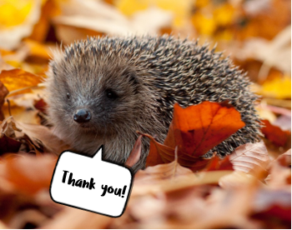
Please send your completed
form to:

Fundraising
Somerset Wildlife Trust
34 Wellington Road
Taunton
Somerset
TA1 5AW

Please don’t send cash in the post.

Got some photos?
We’d love to see them!
If you’re happy for Somerset Wildlife Trust to use them to help promote Look Sharp for Hedgehogs, please email them to fundraising@somersetwildlife.org

Keeping in touch

To find out how we use and protect your personal data and your rights, please see our Privacy Policy:
www.somersetwildlife.org/Privacy_Policy.html

We promise to never sell your details to other organisations. Please tick the boxes that confirm how you would like to hear from us.

Post |  | Email |  | Telephone |  | Text

Please note, if you do not tick any of the boxes we may not be able to share with you details of our work that may be of interest. You can change your communication preferences at any time, by emailing us at membership@somersetwildlife.org or by calling us on 01823 652429.

