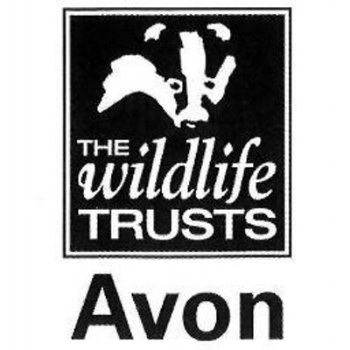

Wild Paths – new careers in nature conservation
Role Title:
Practical Conservation & Engagement Trainee
Based at:
Wiltshire Wildlife Trust – Langford Lakes Nature Reserve, Duck St, Salisbury SP3 4NH
Mentor:
Ashley White – Reserves Field Officer South
Type of work the role will be involved with:
This placement will focus on WWT’s suite of reserves in the south of the county, with a base at our flagship reserve in the Wylye Valley, Langford Lakes. These reserves, many of which are designated as Sites of Special Scientific Interest, support a range of habitats, including unimproved flower-rich grassland, ancient woodland, lakes and wetlands. The trainee will also get the opportunity to work on other reserves in mid and North Wiltshire alongside Reserves and Estates staff.

The trainee will gain experience of:
- Scrub clearance, tree felling and coppicing
- Reserve infrastructure work and site maintenance, including fencing
- Livestock and grassland management
- Survey and monitoring
- Working with and leading volunteers from a wide range of backgrounds
- Community engagement, including guided walks and events
- Media and communication skills
- Health and safety, e.g. risk assessments

All trainees will receive training in key skills, such as time management, personal effectiveness, job applications and interview techniques.

Skills and qualifications you can expect to gain in this role:
- Emergency First Aid at work Level 2
- Health and Safety at work Level 2
- NPTC CS30 & 31 Chainsaw maintenance, cross-cutting & small tree felling
- LANTRA Brushcutter
- Volunteer Management AQA accreditations
- AQA unit award scheme accreditations – options include:
  - Volunteer Management
  - Stock fencing
  - Wildflower identification
  - Tree identification
  - Leading a group
  - Hedgelaying
  - Coppicing
  - Community engagement and inclusion
- 4x4 and quad bike familiarisation
- Species survey and identification skills
- Use of hand tools and appropriate power tools, e.g. mowers, drills
- Knowledge of basic ecological principles, habitat management techniques and relevant legislation

Disclosure and barring checks
A DBS check may be required for participation in certain activities.
Bursary:
£1000 per calendar month for nine months duration
Future progression
This role would provide the ideal background for progression into the conservation sector, working as an assistant warden or ranger.

