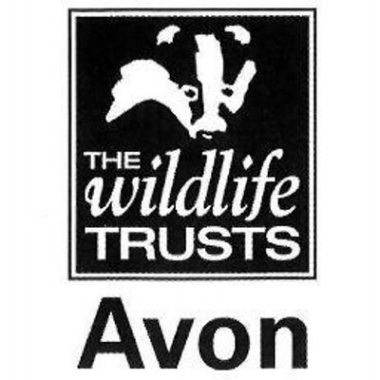

Wild Paths – new careers in nature conservation
Role Title:
Practical Conservation & Engagement Trainee
Based at:
Somerset Wildlife Trust – Ford Farm base nr Taunton
Mentor:
Mark Green – South Somerset Reserves Officer
Type of work the role will be involved with:
This placement is based at Ford Farm near Taunton but the trainees will have opportunity to learn at sites across the Blackdown and Polden Hills in South Somerset. The trainee will be involved in expanding the East Polden volunteer group and in development and implementation of site management plans. The trainee will learn about:
- Scrub clearance, tree felling, coppicing and hedge-laying
- Fencing and reserve infrastructure work
- Surveying and monitoring
- Working with and leading volunteers from a wide range of backgrounds
- Giving guidance and advice to the visiting public
- Community group engagement including school visits, guided walks and events
- Media and communication skills

All trainees will receive training in key skills such as time management, personal effectiveness, interview and application techniques.

Skills and qualifications you can expect to gain in this role:
- Emergency First Aid at work Level 2
- Health and Safety at work
- NPTC CS30 & 31 Chainsaw maintenance, cross-cutting and felling
- LANTRA Brushcutter
- Tractor or 4x4 driving
- AQA unit award scheme accreditations
  - Volunteer Management
  - Conservation grazing
  - Lookering
  - Woodland Management
  - Leading a group
  - Hedgelaying
  - Coppicing
  - Community engagement and inclusion
- Species identification skills
- Ability to use hand tools
- Habitat management and natural history knowledge.

Disclosure and barring checks
This role is unlikely to require a DBS check.
Bursary:
£1000 per calendar month for nine months duration
Future progression
This role would provide the ideal background for progression into the sector, working as an assistant warden or ranger.

