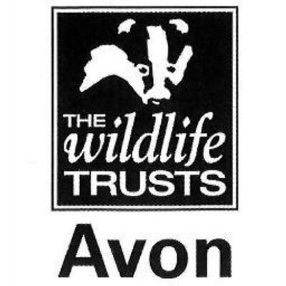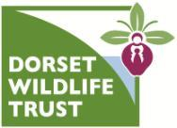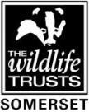

Wild Paths – new careers in nature conservation
Role Title:
Practical Conservation & Engagement Trainee
Based at:
Avon Wildlife Trust
32 Jacobs Wells Road, Bristol BS8 1DR
Mentor:
Rosie Maple or Tim Curley
Type of work the role will be involved with:
Avon Wildlife Trust is the largest local charity working to protect wildlife in the West of England area (formerly the County of Avon - Bristol, Bath and North East Somerset, North Somerset and South Gloucestershire). We care for more than 30 nature reserves, from ancient bluebell woods to Iron Age forts, nationally important wetlands, and wildflower meadows. We run award-winning educational and community programmes and we work with landowners in the wider countryside, to reduce the decline in wildlife by creating a Living Landscape.
This placement will be based at Avon Wildlife Trust’s Office in central Bristol. The trainee will work across the West of England, on reserves, in community settings and at our learning centres at Folly Farm and Feed Bristol.
The trainee will learn about:
- Scrub clearance, tree felling, coppicing and hedgelaying
- Fencing and reserve infrastructure work
- Surveying and monitoring
- Working with and leading volunteers from a wide range of backgrounds
- Engaging with landowners and other stakeholders
- Community engagement and wellbeing programmes
- Urban conservation and wildlife-friendly food growing
- Wild play and outdoor learning
- Media and communications skills

All trainees will receive training in key skills such as time management, personal effectiveness, interview and application techniques.
Skills and qualifications you can expect to gain in this role:
- Emergency First Aid at work Level 2
- Health and Safety at work
- NPTC CS30 & 31 Chainsaw maintenance, cross-cutting & felling
- LANTRA Brushcutter
- Tractor or 4x4 driving
- Volunteer Management AQA accreditations
- AQA unit award scheme accreditations
  - Volunteer Management
  - Conservation grazing
  - Lookering
  - Woodland Management
  - Leading a group
  - Hedgelaying
  - Coppicing
  - Community engagement and inclusion
- Species identification skills
- Hand tool use
- Habitat management and natural history knowledge

Disclosure and barring checks
This role is likely to require a DBS check
Bursary:
£1000 per calendar month for nine months duration
Future progression
This role would provide the ideal background for progression into the sector, working as a conservation or community engagement assistant.

