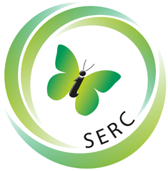
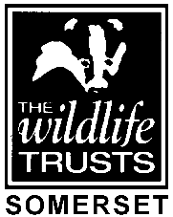

Volunteer Role Outline

Role Title
Committee member, Taunton Deane Area Group
Location
Most activities take place in the Taunton Deane area but members don’t have to be resident in this area
Days and hours volunteer needed
Committee meetings, usually 4 or 5 times a year, and usually only last a maximum of 2 hours. Monthly evening talks in Taunton from October through to April, usually a maximum of 2 hours. Other activities during the year which vary but probably no more than 10 part-days

SWT Role Manager
None
Purpose of role
Support the Area Group Committee in providing a range of talks and related activities and work with Somerset Wildlife Trust on their activities
Tasks involved in this role:
Working with other Committee members to arrange and provide a range of talks and other activities.
Assisting with fund raising activities.
Attend the programme of talks to welcome audience members, collect admission fees if the Treasurer is absent, provide refreshments and provide assistance to speakers if necessary.
On outdoor activities help other participants where necessary. First Aid skills are not required but concern for the welfare of participants and ensuring health and safety advice is followed (through the application of common sense) is important.
Supporting and working with Somerset Wildlife Trust staff on activities, events and public events such as the Taunton Flower Show, where possible.
Increasing public awareness of wildlife in Somerset and the threats to it from Climate Change, development and habitat loss
Benefits to the volunteer:
Feeling of making a difference for Wildlife in Somerset.
“Working” on an informal basis with a small group of friendly and committed people who are not wildlife experts but who care deeply about wildlife in Somerset and consequent social benefits.
Biscuits at Committee meetings!
Skills and abilities needed
Common sense, willingness to be involved and happy to “roll up one’s sleeves and get stuck in” if needed. Outgoing personality. Knowledge of wildlife, whether birds, animals, insects or plants, would be a bonus but is not essential
Expenses
None payable

FOR OFFICE USE ONLY
DBS check required?
Yes / No/ Vulnerable Adult/ Children/ both/ enhanced.
CV required?
Yes / No
Interview required?
Yes / No

